**Data 8 Spring 2020**

**Discussion: Data Types and Table Manipulation (Lab03)**

In lecture, you have been introduced to various *data types* in Python such as integers, strings, and arrays. These data types are particularly important for manipulating and extracting useful information out of data, an important skill for data science. In this section, we’ll be analyzing some of the behavior that Python displays when dealing with particular data types.

Discuss each of the following questions with the people around you.

**1. What Would Python Do?**

For each of the following examples, presume that the code was run in an empty cell. Write down what Python would output. If the code results in an Error, explain why an error would occur.

a. “I love ” + “Data 8”

“I love Data 8”

b. “I love Data ” + 8

This would produce an error message, we cannot put together a string and an int.

c. np.arange(1, 4) + np.arange(2, 7, 2)

array(3, 6, 9)

d. make_array(3, 4, 5) + np.arange(2, 7)

This would produce an error, we cannot add arrays of different sizes.

**2. Fun with Arrays**

Suppose we have executed the following lines of code. Answer each question with the appropriate output associated with the line of code.

odd_array = make_array(1, 3, 5, 7)

even_array = np.arange(2, 10, 2)

a. odd_array + even_array

array(3, 7, 11, 15)

b. odd_array.item(1)

3

c. even_array.item(3) * odd_array.item(1)

24

d. odd_array*3

[ 3, 9, 15, 21]

In this section, we will take a look at working with tables. In particular, we will take a look at how to use Python and functions to manipulate tables for them to show what you are interested in.

**3. eBay Auctions**

Your friend Al is curious to see whether or not it’s cheaper to buy his favorite items on eBay rather than through some other platform! Al stumbles upon some auction data from eBay, and decides to use his newly developed Table skills to do some data-crunching. However, Al is making a few mistakes and needs your help. For the following questions, identify why the code won’t work as is.

The table below is called ebay and contains more than just the 3 rows displayed.

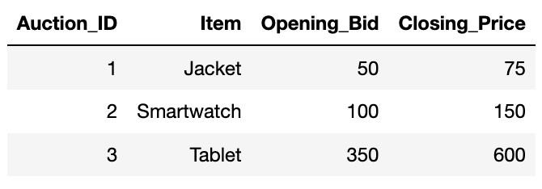

1. # Use comments to describe the code you write  
   ebay.where(‘Opening_Bid’, are.above(60)) / ebay.num_rows

This won’t work because the numerator (ebay.where(‘Opening_Bid’, are.above(60)) is not a number, but it is actually a table. Therefore, we are taking a table and trying to divide it by a number, which means Python will throw an error.

Correct code:

ebay.where(‘Opening_Bid’, are.above(60)).num_rows / ebay.num_rows

1. ebay.column(‘Closing_Price’) - ebay.select(‘Opening_Bid’)

ebay.column(‘Closing_Price’) is an array in Python, while ebay.select(‘Opening_Bid’)is another table. This line of code is attempting to add an array to a table, which will throw an error.

Correct code:

ebay.column(‘Closing_Price’) - ebay.column(‘Opening_Bid’)

or

ebay.column(‘Closing_Price’) - ebay.select(‘Opening_Bid’).column (‘Opening Bid’)

Why does the second one work?

1. Al really wants a new jacket, but his budget is only $150. To see whether eBay has had good deals on jackets historically, Al tries to filter the auction data such that it only contains jackets that were sold for a closing price less than $150. He writes the following code to do so, but hasn’t realized the mistake he’s making. Help Al fix it so that your friend can hopefully get the jacket he deserves!

only_jackets = ebay.where(‘Item’, ‘Jacket’)

jackets_under_price = ebay.where(‘Closing_Price’, are.below(150))

While they assigned only_jackets to a table that only contains Jackets, they are still using the original ebay table in assigning jackets_under_price. Therefore, jackets_under_price will have all items with a closing price underneath 150 dollars, instead of only jackets.

Correct code:

only_jackets = ebay.where(‘Item’, ‘Jacket’)

jackets_under_price = only_jackets.where(‘Closing_Price’, are.below (150))

**4. Violence in California**

You are working on a project related to arrest-related violence in California. After a bit of searching, you finally find some relevant data and import it into your Jupyter Notebook. The table arrests is shown below. (Dataset source: <https://www.kaggle.com/sohier/arrest-related-violence-in-california>)

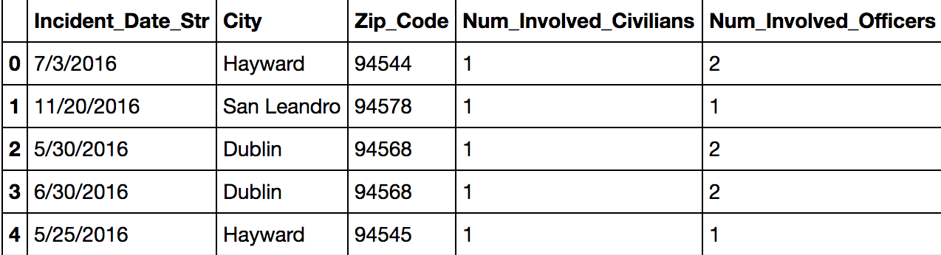

1. Before you start your exploration, you want to understand your data better. For each of the columns **City**, **Num_Involved_Civilians** and **Zip_Code**, identify if the data contained in that column is numerical or categorical.

City: Categorical

Num_Involved_Civilians: Numerical

Zip_Code: Categorical

1. Suppose you were only interested in arrests that involved two, three or four civilians. Assign range_civilians to a table that only contains rows from the arrests table that correspond to arrests involving two, three or four civilians.

range_civilians = _________________________________________________

range_civilians = arrests.where(‘Num_Involved_Civilians’, are.between(2,5))

1. You’re curious about finding out when the arrest involving the most officers occurred in Hayward. Assign arrest_date to a string that represents the date of the arrest that occurred in Hayward that involved the most officers. For this question, assume that the maximum number of officers involved in an arrest in Hayward is unique. It is okay for your code to wrap along the next line for hay_arrests_sorted.

hay_arrests_sorted = __________________________________________________

__________________________________________________________________________

arrest_date = ____________________________________________________________

hay_arrests_sorted = arrests.where(“City”, are.equal_to (“Hayward”)).sort(“Num_Involved_Officers”, descending = True)

arrest_date = hay_arrests_sorted.column(“Incident_Date_Str”).item(0)